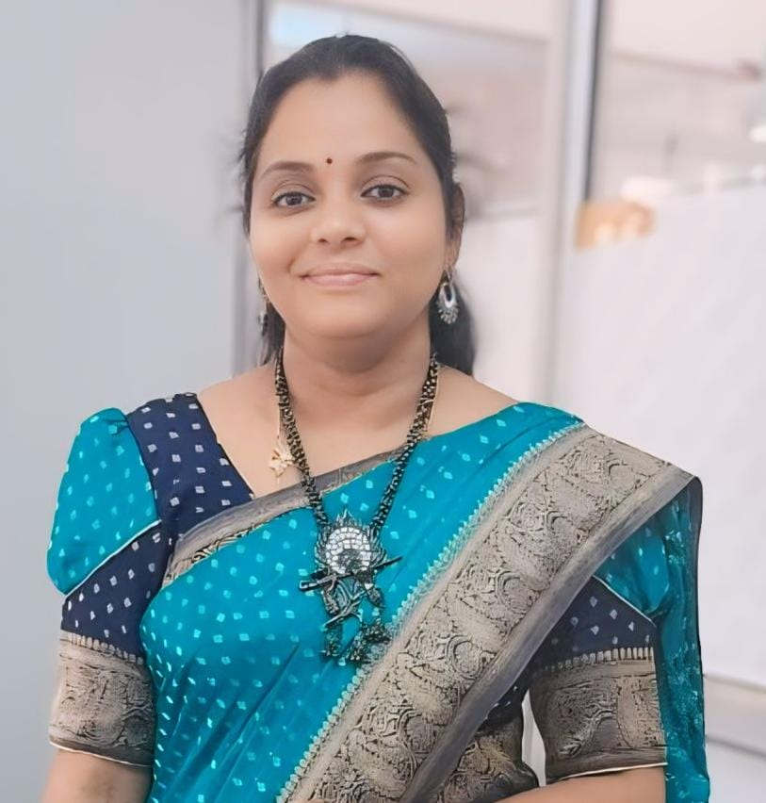

|  |  |  |
| --- | --- | --- |
| **Name** | : | Dr.B.NAGASIRISHA |
| **Date & Place of Birth** | : | 19-07-1983, Nereducharla, Nalgonda Dist,A.P |
| **Present Position** | : | Associate Professor of IoT |
| **Joining date** | : | 11/06/2014 to till date ( 10 year 4 months) |
| **Total Teaching Experience** | : | **19 years 1 month** |
| **Educational Qualification** | : | **Ph.D** from JNTUK, Kakinada.(2024)  M.Tech from JNTUA, Anantapur.(2012)  B.Tech from SVEC ,Suryapet(2005) |
| **Ph.D Guide Details** | : | Dr.V.V.K.D.V. Prasad,Prof. of ECE,  Convenor IQAC,SRGEC, Gudlavalleru. |
| **Patent Details** | : | Total - **3** (Patent **Granted - 1**on Ph.D work,Published-2) |
| **Publication details** | : | Total-**18** (Indexed : SCIE-1, ESCI-1, Scopus-7, other-9) (Under process: SCIE-1, Scopus-4) |
| **Conference details** | : | Total - **4** |
| **Project Details** | : | Total - **2** (SRGEC Internal R&D Project), Submitted - 1, under process - 1, Drafting completed - 1 |
| **Fellowships/Awards/ Other Achievements** | : | FIETE - 503510  MIE-153187-5  Best Paper Award in 2021 |
| **Other Positions** | : | Executive Committee member of IETE, Vijayawada center (2024-2026) |
| **Certification courses** | : | NPTEL - 4, other-3 |
| **Institute & Department level duties in SRGEC** | : | Associate Mentor of ECE, Media center Incharge, Women Protection cell member, Women Empowerment cell member, CIS member, Project coordinator, Feedback coordinator. |
| **Previous college Administrative Experience** | : | Incharge HoD of ECE, Exam branch coordinator, EDC Lab Incharge etc., |